Push project code from local machine into Azure DevOps Repo Using Git Commands:  
=====================================================================

Project details :  
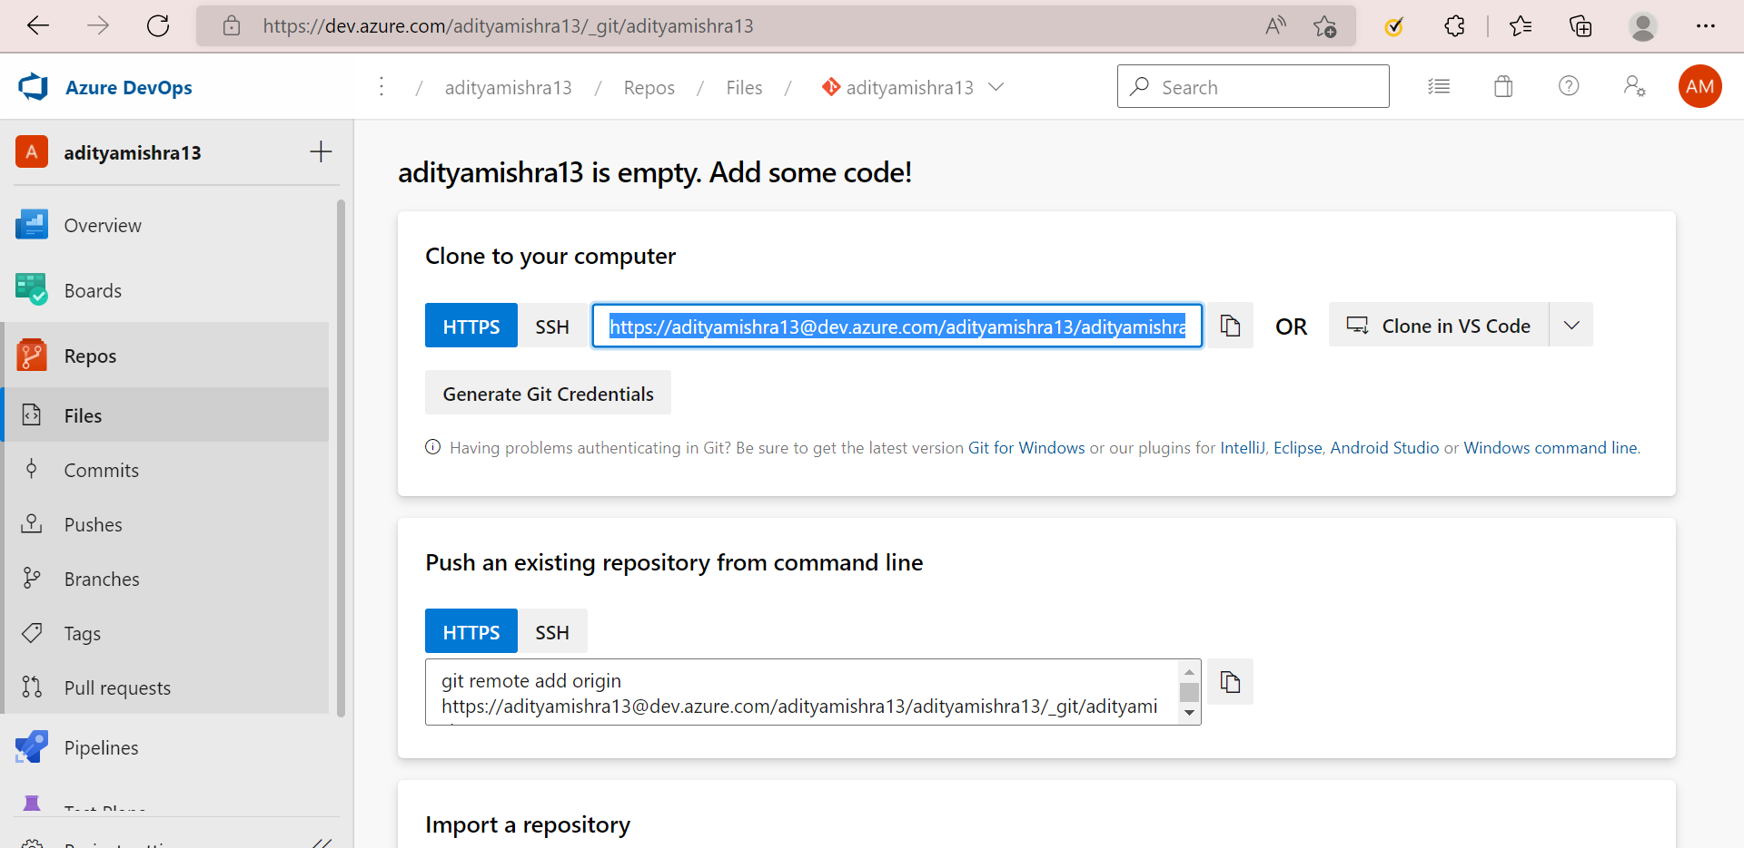

Upload local repository content to a remote repository using git push:

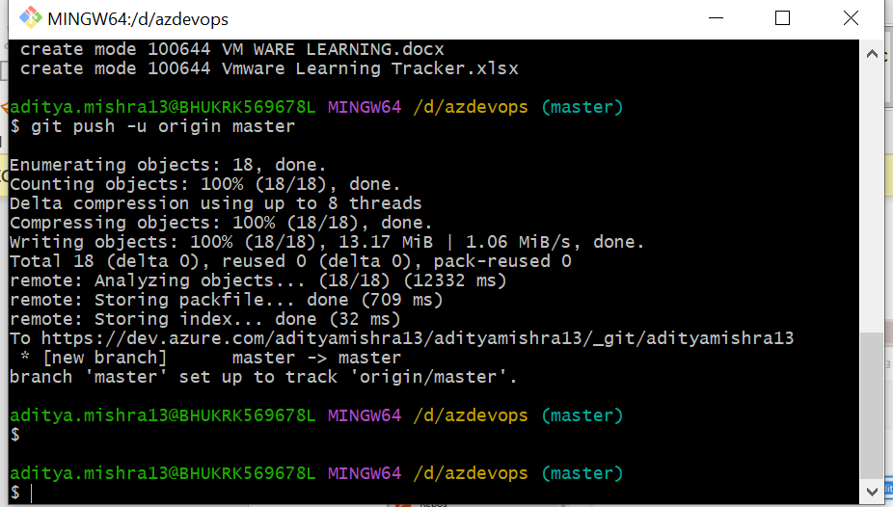

Files uploaded   
